
SUBJECT:
SOFTWARE C&D
6TH

LAB TASK:
MR MUHAMMAD EJAZ
SUBMITTED TO:
AFTAB GHANI
SUBMITTED BY:
DEPARTMENT:
SOFTWARE ENGINEERING
CU ID:
4329-2023

SEMESTER:
5TH
DATE:
09-01-2026

CECOS UNIVERSITY OF IT & EMERGING SCIENCE HAYATABAD, PESHAWAR

LAB 06
1. A banking system needs to protect account balance details.
Create a Bank Account class where the balance is private and can only be accessed using
deposit and withdraw methods.
Code:
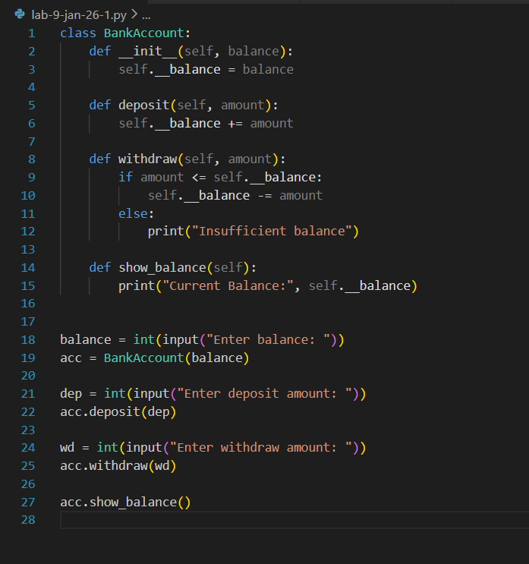

Output:
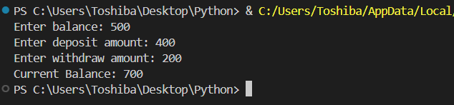

2. A school management system stores student marks securely.
Create a student class with private attributes for name and marks and display them
using public methods.
Code:
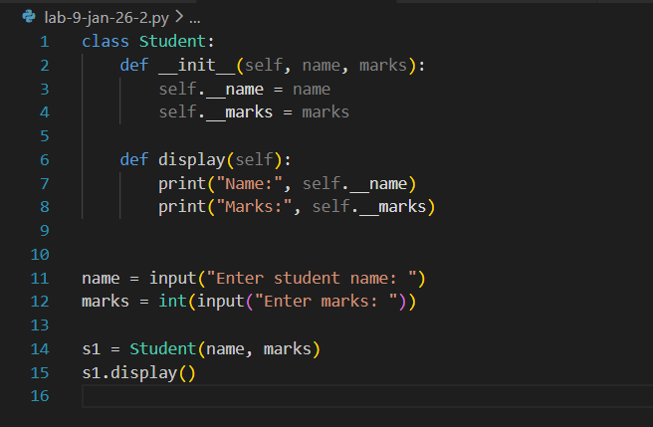
Output:
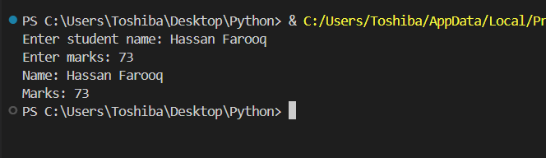

3. A company payroll system should not allow direct access to salary data.
Create an employee class with a private salary attribute and methods to update and
display the salary.
Code:
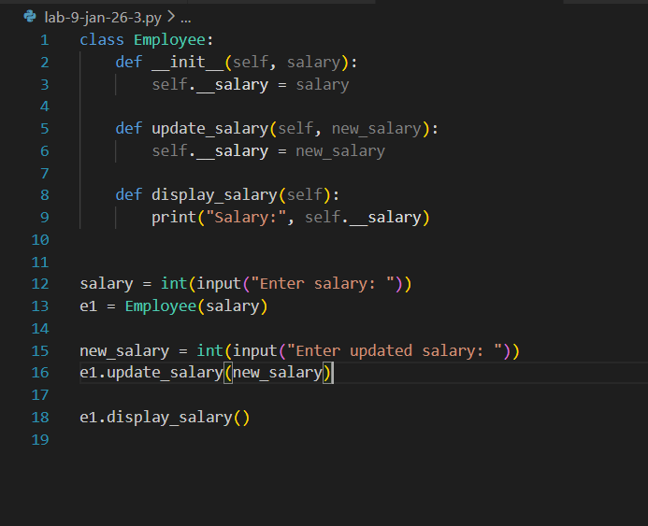
Output:
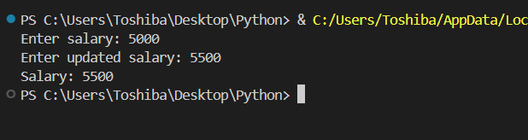
4. A vehicle showroom stores basic vehicle details.
Create a Vehicle class with attributes like brand and model, and a Car class that inherits
from Vehicle and displays them.
Code:
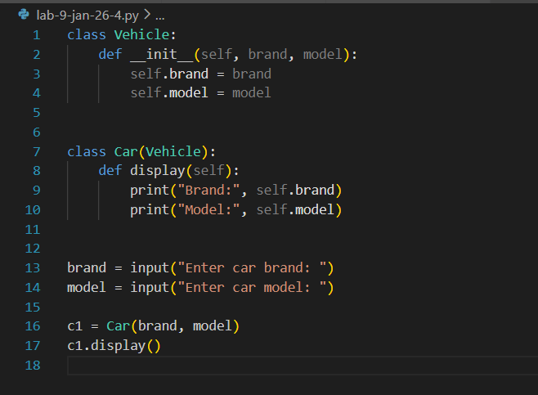
Output:
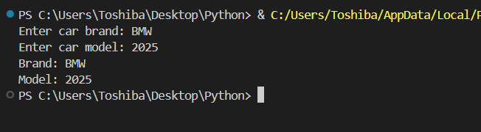
5. A college database stores personal details of people.
Create a Person class with name and age, and a student class that inherits from Person
and displays student details.
Code:
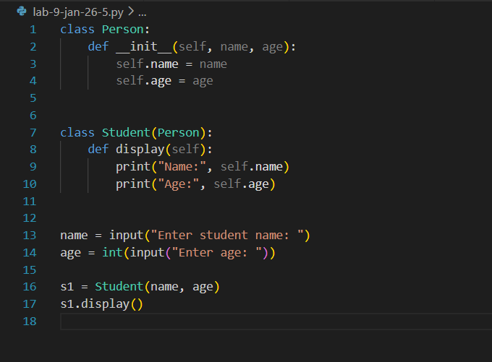
Output:
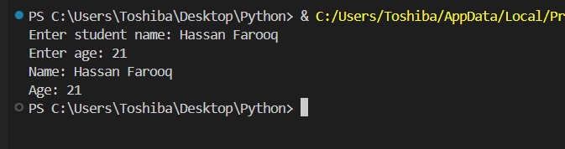

6. In a family hierarchy system, details pass from older to younger generations.
Create a Grandparent class, a Parent class that inherits from it, and a Child class that
displays family details.
Code:
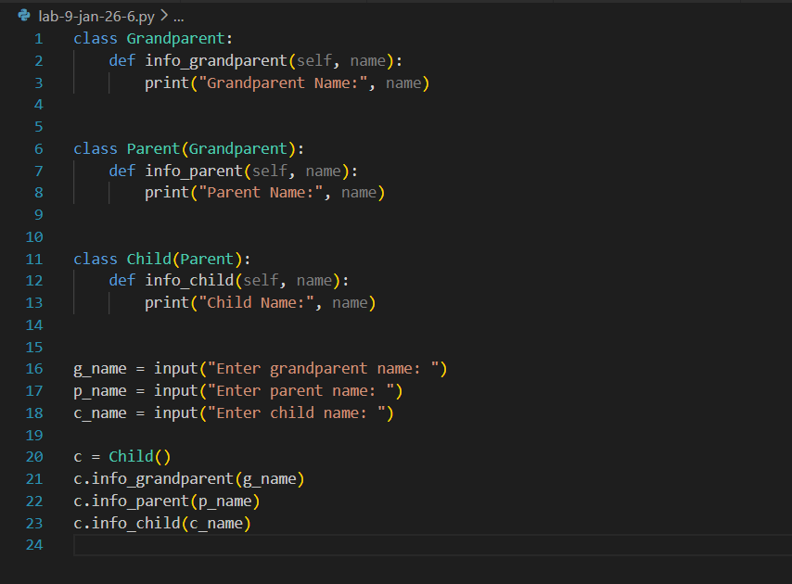
Output:
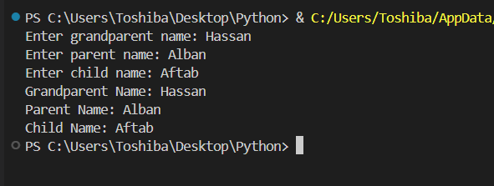

7. A technology product system classifies devices step by step.
Create a Device class, a computer class that inherits from Device, and a laptop class that
inherits from Computer and displays the brand.
Code:
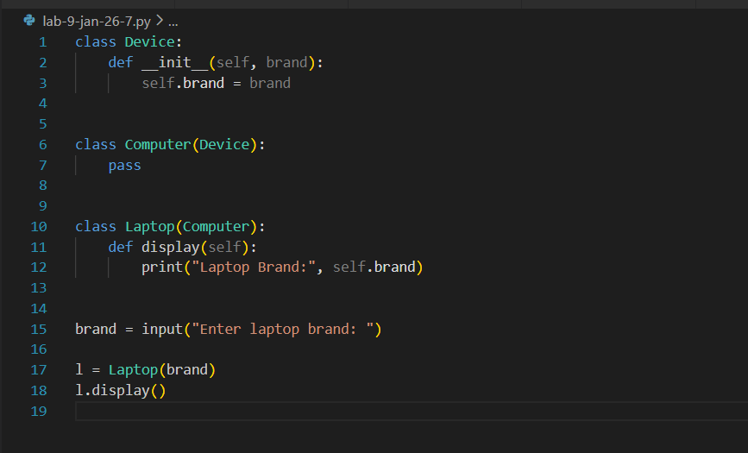

Output:
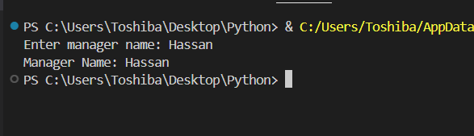
8. In a company structure, employees have different roles.
Create a Person class, an employee class that inherits from Person, and a manager class
that inherits from Employee and displays the person’s name.
Code:
class Person:
def __init__(self, name):
self.name = name

class Employee(Person):
pass

class Manager(Employee):
def display(self):
print("Manager Name:", self.name)

name = input("Enter manager name: ")

m = Manager(name)
m.display()

Output:
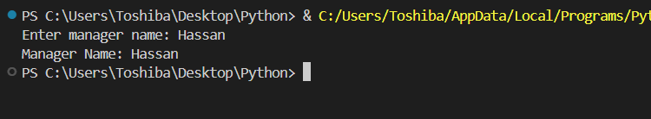

9. A student activity system tracks both academic and sports participation.
Create an Academics class and a Sports class.
Create a student class that inherits from both and displays academic subject and sport
name.
Code:
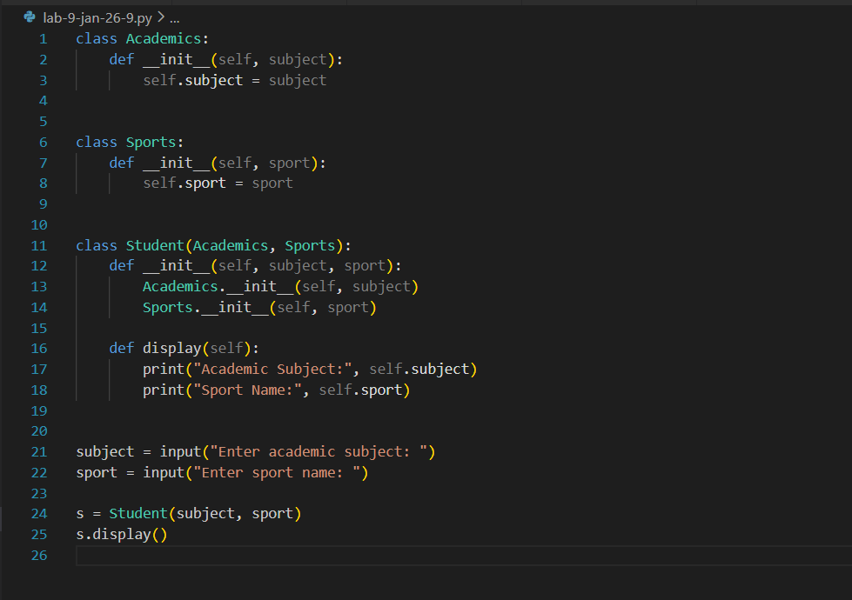

Output:
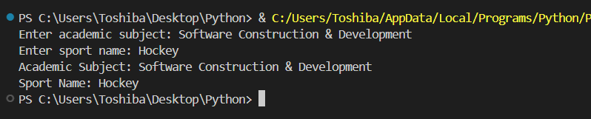

10. A smart device has features from different systems.
Create a Camera class and a Music Player class.
Create a Smartphone class that inherits from both and displays camera and music
features.
Code:
class Camera:
def __init__(self, camera_feature):
self.camera_feature = camera_feature

class MusicPlayer:
def __init__(self, music_feature):
self.music_feature = music_feature

class Smartphone(Camera, MusicPlayer):
def __init__(self, camera_feature, music_feature):
Camera.__init__(self, camera_feature)
MusicPlayer.__init__(self, music_feature)

def display(self):
print("Camera Feature:", self.camera_feature)
print("Music Feature:", self.music_feature)

camera = input("Enter camera: ")
music = input("Enter music: ")

phone = Smartphone(camera, music)
phone.display()

Output:
